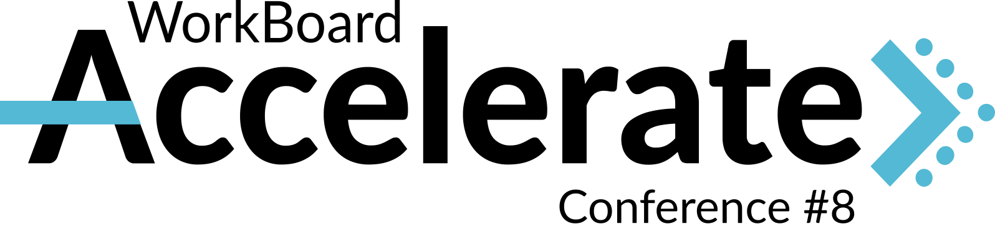

**September 30 – October 2, 2024**  
La Jolla – San Diego, California  
In Person Conference

**WorkBoard Accelerate Conference – Request to Attend**

Hi [Name],

I’m requesting your approval to attend [WorkBoard Accelerate](https://www.workboard.com/accelerate2024/), taking place September 30 - October 2, 2024, at the Estancia La Jolla Hotel and Spa in San Diego, CA. Celebrating its 8th year, Accelerate has established itself as the ultimate conference for Strategy Execution and OKR leaders to learn best practices from the field and build our strategy execution networks.

# **Conference Overview** Accelerate is an annual conference hosted by WorkBoard, the thought leader in strategy execution for enterprise organizations. The three-day conference brings together expert speakers, results management leaders, and OKR practitioners from across industries to share their real-world learnings, unpack strategy execution best practices, and explore development in technology including new WorkBoard core and AI features.

The most recent conference, Accelerate 2023, brought leaders together in person over 3 days in Scottsdale, Arizona. You can view the [2023 Highlights](https://www.workboard.com/accelerate2024/#about) to get a better idea of the type of content we can expect at Accelerate 2024.

# **How will our company benefit from my attendance at Accelerate?**

## **Continued education with in-person keynotes and deep dives**

Each day of the conference, we’ll hear keynotes and presentations from strategy execution leaders from companies like Boeing, Mars Inc., and Twilio, along with prominent OKR thought leaders. Throughout the day, we’ll have the opportunity to join intimate group conversations on strategy execution topics such as:

* Tactics to improve key result integrity
* The role of Chiefs of Staff in your operating cadence
* Leveraging the exponential power of OKR coaches
* Building a new-hire onramp to great OKRs and WorkBoard
* And much more!

The WorkBoard team will facilitate each group conversation to ensure we’re provided with the latest best practices, hands-on training, and follow-up materials.

## **Key platform demos and AI feature updates**

Each year, WorkBoard introduces the most impactful platform features and AI capabilities at Accelerate. Being able to attend in person will not only give me the opportunity to ask questions directly to the WorkBoard team hosting the sessions but will also prepare me to leave the conference feeling ready to implement these new features into our operating rhythm. I will be able to bring all those learnings back into the company and level up my peers.

## **Connecting with leading professionals in our field** Accelerate brings together 100+ of the top strategy execution practitioners from across industries. This is a unique networking opportunity for us as capture strategy execution and OKR best practices from across industries and business units. This event will take place at a critical time when we are reflecting on how we performed in 2024 and recalibrating as we head into the new year. I’m excited to bring learnings back to our team as we prepare for our next OKR setting sessions.

# **Conference Details**

**Date: September 30 – October 2, 2024**

**Location:** Estancia La Jolla Hotel & Spa, San Diego, California

**Conference Cost: E**

**Early-Bird Pricing is available through June 30th:**   
$499 Individual Ticket  
$799 Bring a peer (Two tickets)

**Pricing July 1st onward:**  
$699 Individual Ticket  
$999 Bring a peer (Two tickets)

**Cost includes:**

Access to three days of tailored programming, including inspirational keynotes,

product deep dives, AI feature demos, intimate breakout sessions, networking

events, and more. Ticket includes light meal at reception on September 30, all

meals on October 1, breakfast and lunch October 2, and conference materials.

**Venue**:

Estancia La Jolla Hotel & Spa is centrally located in the heart of La Jolla, San

Diego. Special rate of $314/night (including resort fees) for Accelerate attendees from

September 29 - October 2.

**Additional information and full agenda:** <https://www.workboard.com/accelerate2024/>

P.S. Here’s what a few Accelerate attendees are saying about the last conference:

**“This is a community of like-minded people who are open and honest about the business challenges we’re facing, and eager to address those challenges together.”**

Stephanie Waldorf – Chief of Staff, UnitedHealth Group

**“I’m walking away with so many actionable insights that I’m excited to put right into practice.”**

Molly Dixon – Director, Enterprise Program Management Office, Lytx

